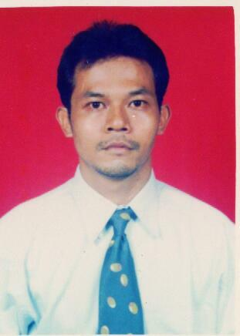Muhammad Ali fahmi
Personal detail
Place/Date of brith : Jakarta, 1st April 1972
Marital
Married
Experience
13st Agustus 2007 – Until Now
PT. Megapolitan Group Property & Developer Limo – Depok .
* Project Manager / Chief Engineering Salary Rp. 5.500.000
Reference: Mr. Ir. Toton Naolase Msc Hp. 0816805660 Director Operational PT. Megapolitan
Mrs Ir. Lanny Darmawan Hp. 0818824288 General Manager Mall Cinere (PT Megapolitan Group)
24st Januari 2000 – 10st Agustus 2007
PT. Japfa Santori Indonesia Tangerang.
* Project Engineer, Supervisor Maintenance Building & Utility Salary Rp. 3.500.000
Reference: Mr Ir. Asrul Ointu Hp. 0816735709 Plant Manager PT. Japfa Santori Indonesia
Mr. Ir. Achmad Djajang K Hp. 0818589886 Maintenance Manager PT. Japfa Santori Indonesia
1st Desember 1998 – 15st Januari 2000
PT. Krishna Utama General Contractor Jakarta.
* Site Engineer. Salary Rp. 1.200.000
* Estimator Project.
Reference: Mr Ir. Alex Ilalang Project Manager PT. Krishna Utama
1st April 1994 – 31st Maret 1998.
Depertment of public work, directorate general Bina Marga road & Bridge,
Development & Maintenance Project Malang & Gempol – Malang – Turen East Java.
* Site supervisor project. Salary. Rp 450.000
Reference: Mr Ir. Eddy Mulya Project Manager
Mr. Sukarjo BE Assisten Project Manager
1st April 1992 – 31st Maret 1994.
Depertment of public work, directorate general Bina Marga road & Bridge,
Development & Maintenance Project Babat East Java.
* Staff Engineering. Salary Rp. 250.000
Reference: Mr Ir. Moulani Project Manager
Mr. Ir. Mirza Affandi Project Officer
Education
1993 – 1998 University of katolik Widya Karya Malang. Majori Civil Engineering. East Java.
1988 – 1991 SMA Negeri 2 Lamongan East Java.
1985 – 1988 SMP YPUI. Jakarta.
1979 – 1985 SD Negeri 18 Jakarta.
Couses
2008 Property Management Course (GMT Institute of Property Management) Jakarta.
Core Course
1. Introduction to property 7. Fire and safety
2 How to be Effective Manager 8. Mechanical & Electrical Systemn
3. Legal Aspect in property 9. Overview Accounting /Finance / Budget
4. Overview property Management 10. Budget
5. Housekeeping 11. Fit Out Regulation
6. Security 12. How to Reevaluate Electricity Comsumption
2000 Autocad Reales 14 Jakarta.
1995 Mix Design Concrete Structur at University of Brawijaya Malang. East Java.
Training
2008 Super Team Rich ( Action Coch Bisnis Coching) Cinere - Puncak
2007 Total Productiev Maintenance (TPM) HRM Corporate Training & Cumunication Japfa Group. Cikande
2004 Interpretation of ISO 9001 : 2000 ( Bisnis Excellence Counsulting Jakarta) Tangerang - Jakarta
2004 Supervisi Tenaga Kerja (Program Pembelajaran Manajent PPM Jakarta) Tangerang - Jakarta
2003 Japfa Leadershif – 1 HRM Corporate Training & Cumunication Japfa Group. Tangerang - Puncak.
2001 Workshop 5S HRM Corporate Training & Cumunication Japfa Group. Tangerang.

komplek mabad 55 rt 02 / rw 11 no. V 321 rempoa
ciputat phone (021) 7424962. Hand Phone 081310772988.
E-Mail:ali_fahmi_haikal@yahoo.co.id

